COMMUNICATIONS TOOLKIT

Background

About ICON

The idea for the ICON programme and the different interventions within it was conceived by Dr Suzanne Smith PhD following a Winston Churchill Memorial Trust Travel Fellowship to the USA and Canada in 2016 which included the study of effective interventions and research into the prevention of Abusive Head Trauma (AHT). Research suggests that some lose control when a baby’s crying becomes too much. Some go on to shake a baby with devastating consequences.

Suzanne found that the most effective evidence-based programmes studied provide a simple message that supports parents/caregivers to cope with infant crying. Apart from preventing AHT, most people who have ever cared for a baby appreciate some advice about comforting a crying baby and coping when it goes on for a long time.

ICON is about helping people caring for babies cope with crying.

ICON stands for ….

I Infant crying is normal
C Comforting methods can help
O It’s OK to walk away
N Never, ever shake a baby

Speak to someone if you need support such as your family, friends, midwife, GP or health visitor.

More information and a wealth of resources are available on the ICON Cope website – www.iconcope.org

Hull City Council are working in partnership with colleagues from East Riding Council, NHS Humber and North Yorkshire ICB and Humber Teaching NHS Foundation Trust to raise awareness of support available in Hull for parents and carers of babies.

NEWS for families – NEWSLETTERS or website news stories
Each partner service will need to add in their own information and relevant contact or is there one service applicable to all partners involved

Raising Awareness of ICON in Hull

Babies cry! Infant crying is normal and it will stop. A baby’s cry can be upsetting and frustrating. It is designed to get your attention and you may be worried that something is wrong with your baby. Your baby may start to cry more frequently at about 2 weeks of age. The crying may get more frequent and last longer during the next few weeks, hitting a peak at about 6 to 8 weeks. Every baby is different, but after about 8 weeks, babies start to cry less and less each week.

What can I do to help my baby?
Comfort methods can sometimes soothe the baby and the crying will stop. Babies can cry for reasons such as if they are hungry, tired, wet/dirty or if they are unwell. Check these basic needs and try some simple calming techniques:
• Talk calmly, hum or sing to your baby
• Let them hear a repeating or soothing sound
• Hold them close – skin to skin
• Go for a walk outside with your baby
• Give them a warm bath

These techniques may not always work. It may take a combination or more than one attempt to soothe your baby. If you think there is something wrong with your baby or the crying won’t stop speak to your GP, Midwife (Tel 01482 382658) or Health Visitor (Tel 01482 259600). If you are worried that your baby is unwell call NHS 111.

What not to do…
Handling a baby roughly will make them more upset. Shouting or getting angry with your baby will make things worse. Sometimes parents and people looking after babies get so angry and frustrated with a baby’s cry, they lose control. They act on impulse and shake their baby.

Shaking or losing your temper with a baby is very dangerous and can cause:
• Blindness
• Learning disabilities
• Seizures
• Physical disabilities
• Death

For more info please contact your family hubs www.familyhubshull.org.uk, your GP, Midwife (Tel 01482 382658) or Health Visitor (Tel 01482 259600).

resources for professionals

eLearning
eLearning is available for any professionals working with families via the Icon cope website, accessible here: ICON eLearning – Babies cry, you can cope (iconcope.org). This training is designed to equip you with the knowledge, information, and skills that you will need to discuss ICON: ‘Babies cry, you can cope’ with parents and carers. The training will help you to share the message that crying in babies is normal, support parents/carers to soothe their baby, support parents to cope with a baby’s crying and understand more about abusive head trauma.

To access the eLearning the user will need to select register and create an account using a username and password.

Once complete, users are encouraged to download the certificate and share it for their individual records.

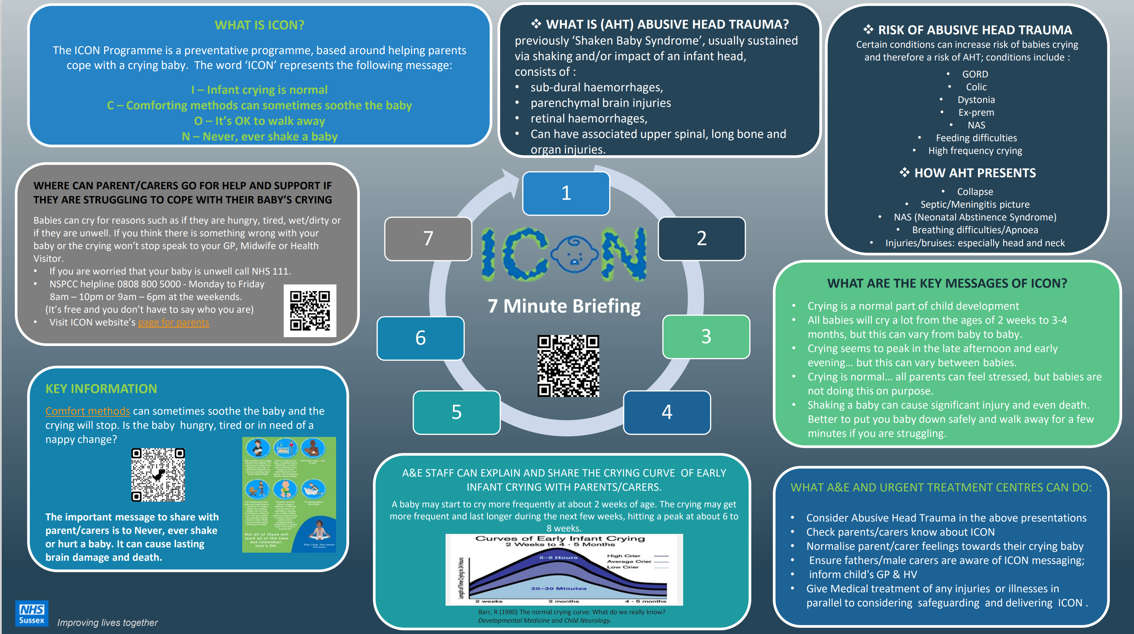

ICON have delivered webinars with NHS partners across the country focussing on delivering the ICON message to different stakeholder groups. Links are available to staff, to learn more about:
- Awareness of abusive head trauma and Icon within the multi-agency
- Perinatal Health
- The myth of the missing male
- Dad matters
- ICON in general practice

All webinars are available on YouTube: ICON Week 2023 - Thursday - ICON in general practice (youtube.com)

Downloadable resources
The ICON website has various resources available to download including posters and leaflets, all of these are translatable. Access them here: Resources - ICON Cope

Website and Intranet copy

This week (Monday 19 February to Friday 16 February 2024) we are promoting ICON Week in Hull. The aim of the week is to raise awareness of infant crying and ways parent and carers can cope. In doing so we will prevent serious injury, illness and even death of young babies as a result of abusive head trauma that happens when someone shakes a baby.

ICON is a programme adopted by health and social care organisations in the UK to provide information about infant crying, including how to cope, support parents/carers, and reduce stress.

For more information, you can speak to your local Family Hub, or please visit www.iconcope.org

INTERNAL NEWSLETTER CONTENT – FOR PROFESSIONALS

ICON: ‘Babies cry, you can cope’

ICON week in Hull – sharing information to help prevent abusive head trauma.

Research points to persistent crying in babies being a potential trigger for some parents/caregivers to lose control and shake a baby. It also shows that around 70% of babies who are shaken are shaken by men. However, we know that Infant crying is normal and it will stop. A baby’s cry can be upsetting and frustrating for the family home. As professionals we understand that it is designed to get parents attention however some may be worried that something is wrong with their baby.
In Hull we have a range of training to support you in supporting families when babies cry. The training will help you to:
  - share the message that crying in babies is normal
  - support parents/carers to soothe their baby
  - support parents to cope with a baby’s crying
  - understand more about Abusive Head Trauma
  - understand it is a form of child abuse

Some of the messages are also embedded in other training, please access the most suitable for yourself:
- Vulnerability of babies - please access the Hull City Council Learning and Development training calendar and book on via OLM (if internal) or emailing LearningandDevelopment@hullcc.gov.uk if you work across the partnership.
- Early Help staff refresher training – please contact Lisa Howell lisa.howell@hullcc.gov.uk for webinar training dates.
- Online refresher training – via https://training.iconcope.org/ enter a username, e mail and create a password to access to a home page, select the course, complete the course and receive the downloadable certificate. Please see Professionals - ICON Cope for further details

Social media CALENDAR
MONDAY 19 February | If you have a baby that cries a lot, it can be exhausting and lonely. You are not alone.  Crying is normal. It is not your fault. It's ok to take a time out when you feel overwhelmed.  Keep baby safe, keep yourself safe.  #ICONcope  https://iconcope.org/
TUESDAY 20 February | Abusive head trauma can occur in any environment when a parent or carer is on the edge due to infant crying.  Make sure anyone looking after your child knows the ICON principles. https://iconcope.org/parentsadvice/  #ICONcope | 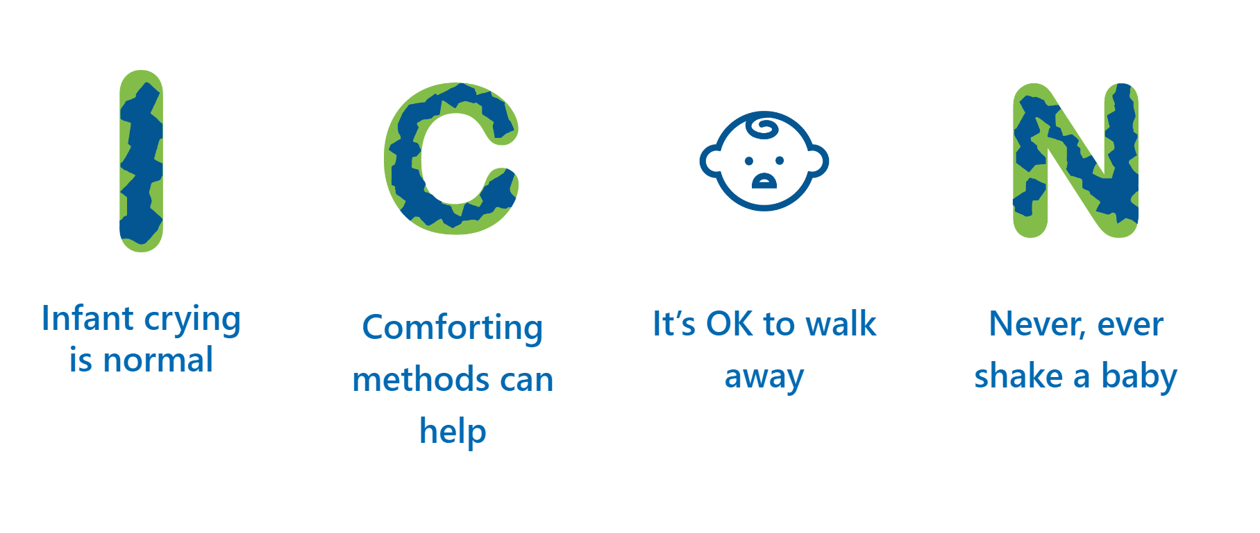
WEDNESDAY 21 February | There are lots of things you can do to help soothe your baby. Check out our top tips to help with infant crying. The main thing to remember is to stay calm and never hurt or shake your baby. #ICONcope  https://iconcope.org/ | 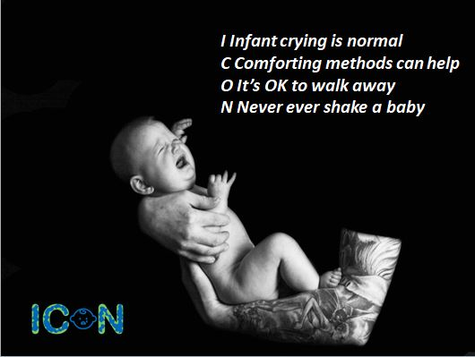
THURSDAY 22 February | It's good to talk. Coping with a crying baby can be stressful, so don’t forget to discuss your ICON Coping with Crying Plan with your Health Visitor or Midwife, so they can offer you support and advice.  #ICONcope  https://iconcope.org/ | 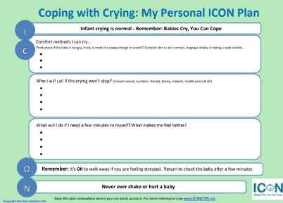
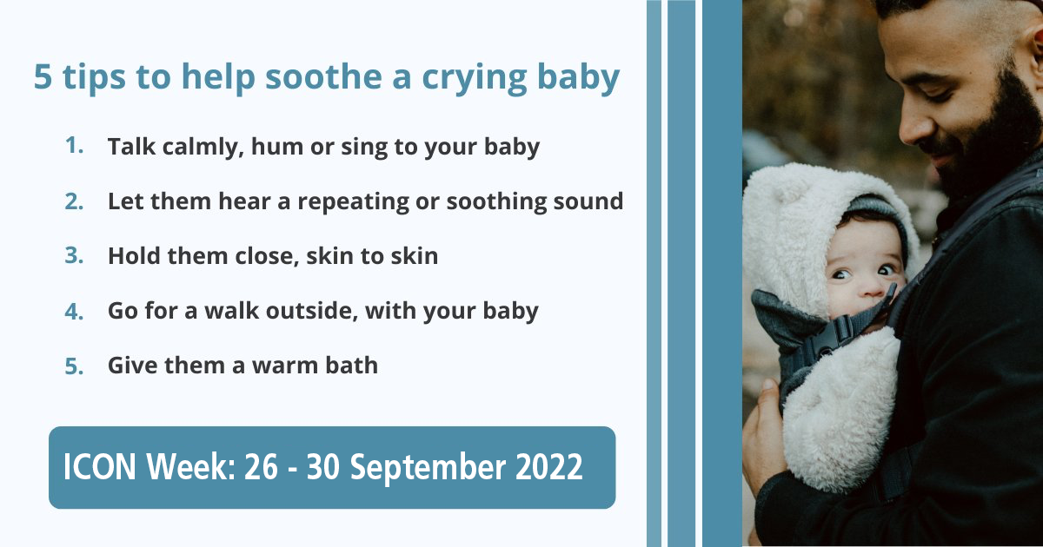FRIDAY 23 February | It’s tough when your baby won’t stop crying. You may worry something is wrong with your child, that you’ll lose your cool or that your parenting skills aren’t up to the job. But you can handle it!  * Take a break  * Ask for help  NEVER SHAKE YOUR BABY!  #ICONcope  https://iconcope.org/ | 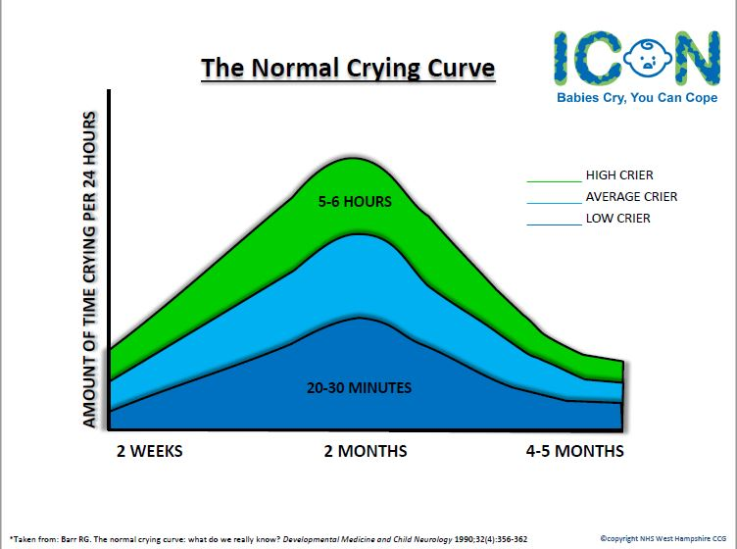

All of the original ICON videos can be used in addition to the graphics above, download here: Download all of the videos and graphics here.

ADDITIONAL TARGETTED GRAPHICS

ICON have created posters specifically to parents and carers of babies with cleft pallets.

